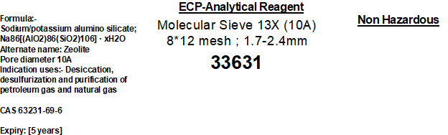
Name | Size | Static H₂O Adsorption Capacity | Size Ratio | Crush Strength | Bulk Density | Packing Moisture
M.S.13X | 1.6 – 2.5 MM (8x12 mesh)  Pore size 3A (3 Angstrom) | ≥24.0% | ≥98.0% | ≥70.0N/p | ≥0.60g/ml | ≤1.5%

